2.1 milestone adjustments.

1. Profile for non-authorized user
   1. Add webinar tab with webinars
   2. Courses tab should display only courses excluding webinars
   3. If no courses or webinars for particular user hide corresponding tab
2. Profile -> Instructor -> Courses (missed in 2nd milestone)
   1. Display only courses exclude webinars
   2. Add message You cannot create new courses because you already have 3 courses in draft. For > and = 3 courses
   3. Search filter should work only for courses

Profile -> Instructor -> Webinars (missed in 2nd milestone)

* 1. Search filter should work only for webinars

Profile -> Student -> Courses (missed in 2nd milestone)

* 1. Display only courses exclude webinars
  2. Search only Courses
  3. finished filter replace In Progress

Profile -> Student -> Webinars (missed in 2nd milestone)

* 1. Search only Webinars
  2. finished filter replace In Progress

1. Profile -> Student menu -> Additional -> My Orders
   1. add Action Pay which opens Payment link if order in Pending status (function get_checkout_payment_url())

add_action( 'wp_head', 'insert_test');

function insert_test() {

$order_id = 10900;

$order = wc_get_order( $order_id );

$link = $order->get_checkout_payment_url();

// wp_die('Link ' . var_dump($link));

}

* 1. delete recover area 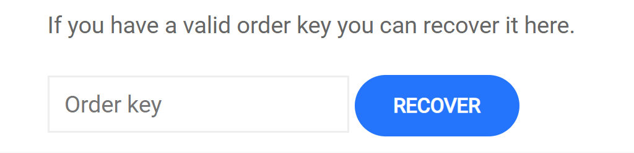

1. Profile -> Student -> Quizzes
   1. Tabs (All Passed Failed) as drop-down filter
2. Profile -> Student -> Assignments
   1. Tabs (All Not Evaluated Passed Failed) as drop-down filter
3. Frontend Profile Settings -> General
   1. Add learnpress profile links (Major, Facebook, Twitter, Instagram, Google Plus, LinkedIn, Youtube). Now it is available only in backend

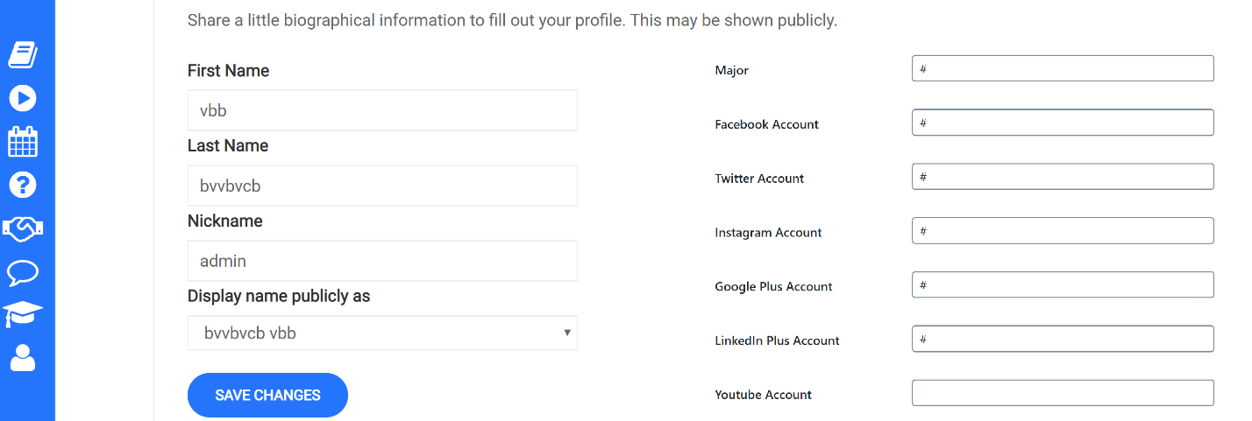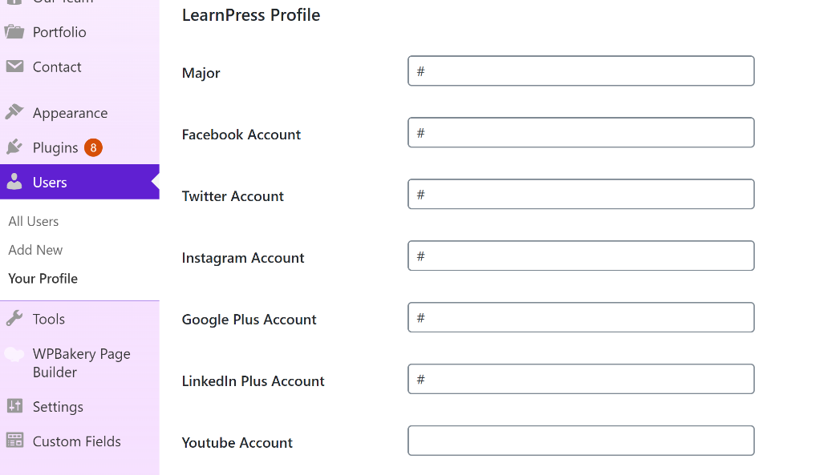

1. Profile -> Instructor -> Assignments (point 14, 2nd milestone)
   1. Second milestone created some errors with Assignments. (Not possible to add assignments to course in backend, not possible to add assignments to course/webinar in Frontend, student cannot send assignment for approval) (point 14, 2nd milestone)
   2. Add Assignments page with received assignments from students (point 14, 2nd milestone). Similar to Profile -> Instructor -> Gradebook

### Assignments

| **Course/Webinar course** | **Not evaluated** | **Evaluated** |
| --- | --- | --- |
| [Создание онлайн-продукта: техника digital customer development](https://digitalcustdev.ru/profile/abwf8465/gradebook/course/7216) | 2 | 10 |

Clicking course

Pic from gradebook/courses/id

|  |  |
| --- | --- |
| **Course/Webinar course** | [Создание онлайн-продукта: техника digital customer development](https://digitalcustdev.ru/courses/master-digital-custdev/) |
| **Instructor** | Система |

Начало формы

 ФИЛЬТР

Pic from backend Assignments

| Student | [Status](https://digitalcustdev.ru/wp-admin/admin.php?page=assignment-student&assignment_id=10725&0&assignment-nonce=385e0a98a8) | Mark | [Result](https://digitalcustdev.ru/wp-admin/admin.php?page=assignment-student&assignment_id=10725&0&assignment-nonce=385e0a98a8) | Actions |
| --- | --- | --- | --- | --- |
| test1 | [С оценкой](https://digitalcustdev.ru/wp-admin/admin.php?page=assignment-student&assignment_id=10725&assignment-nonce=385e0a98a8&filter_status=evaluated&filter_result=failed) | 3 | [Непройденные](https://digitalcustdev.ru/wp-admin/admin.php?page=assignment-student&assignment_id=10725&assignment-nonce=385e0a98a8&filter_status=evaluated&filter_result=failed) |  |

* 1. 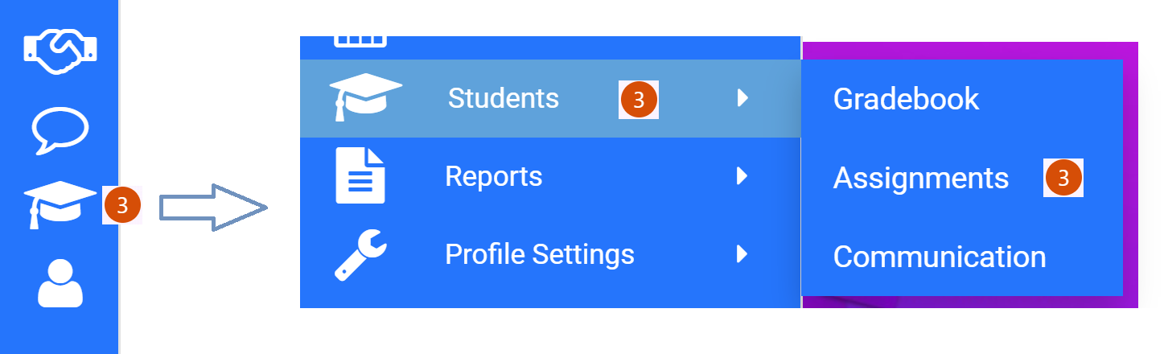Add bubble counter notification for received not evaluated assignments

1. Mobile menu for Profile Page
   1. Create mobile menu for Profile Page for Instructor/Student view

